**Personal, Relevant Background and Future Goals Statement**

# Motivation and Preparation to Pursue an Advanced Degree

When I was in fifth grade, my dad gave me my first electrical kit (a series of simple electrical components arranged on a breadboard). When I wired things up properly, I was able to ring a bell, or turn on a light. The science behind these experiments is simple, but I was hooked. Throughout my early education, I learned of the technologies that have shaped the way we live, and I knew that I wanted to develop something that could change the world. This desire led me to pursue a degree in mechanical engineering. During my undergraduate studies, I discovered that I had an aptitude and love of controls and robotics, and I found that the best way to get involved with robotics research that would benefit society was to pursue a graduate degree. Nelson Mandela said, “Education is the most powerful weapon which you can use to change the world”. My education will empower me to have a career where I can perform cutting edge research, provide for my family, and benefit society. The following sections highlight a few of the most prominent experiences that have prepared me to push forward the frontiers of research in controls and robotics and perform work that will benefit society.

## Los Alamos Dynamic Summer School – 2014

Los Alamos National Laboratory (LANL) was my first exposure to the world of research. In a disaster scenario, humans on foot can take a long time to navigate unsafe terrain to locate people who need help. Unmanned aerial vehicles (UAVs) are one of the most promising technologies in the effort to improve this response time as they could quickly locate survivors and direct responders accordingly. In many disaster scenarios, UAVs would need to fly indoors to find people. One of the challenges in flying a UAV indoors via onboard visual feedback is encountering reflective and transparent barriers. Glass office partitions, windows, and mirrors can confuse the operator (or autonomous navigation system), reducing the ability to accurately identify the location of people who need rescue. During this nine-week fellowship, I worked with two other students to design a multimodal sensing system capable of determining 1) whether a barrier was transparent, reflective, or opaque and 2) the distance and angle of approach to that barrier. I personally came up with the system architecture we ultimately chose to use, headed the mechanical design of our prototype, and designed and implemented the algorithms for determining the distance and angle of approach to the barriers.

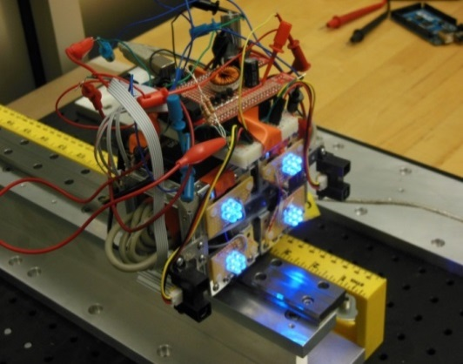

*Figure 1: Transparent barrier detection prototype*

By the end of the fellowship, we had built and tested the successful prototype shown in *Figure 1*. We published our research in an SPIE conference paper [1], and I had the opportunity to individually travel to the conference to present our results. Working as a researcher at LANL left me amazed at the depth of knowledge my mentors possessed. They were able to guide us to the most viable solutions of our difficult research problems while performing impactful research of their own. During this experience, I developed a strong desire to become a technical expert so that I too could help younger researchers and contribute to the solutions of the nation’s most difficult problems.

## BYU Tactile Sensor Development - 2015

After my experience at LANL, I sought out more research opportunities at Brigham Young University (BYU). Being particularly interested in dynamics and control, I decided to get involved with the BYU Robotics and Dynamics (RaD) Lab under the direction of Marc Killpack. Before joining the lab, I was required to have a certain skill level in Python, Linux, and other third party robotics software libraries. To compensate for my lack of knowledge in these areas, I spent much of my time outside of class and work completing tutorials and developing the necessary skills. As a result, I was able to join the lab and gain more research experience. This demonstrates my drive to succeed and ability to overcome obstacles in my path, both skills that have and will continue to benefit me as a researcher. At the RaD Lab, we work with pneumatically actuated soft robots. These soft robots are inherently safer around humans than traditional robots with high gear ratios. I led a team of three other undergraduate students to develop a fabric tactile sensor that wrapped around the inflatable robots to provide force feedback for control implementation. I wrote both the microcontroller code to collect data from the sensor, as well as the Python code to implement the sensor with the robots in the lab. This sensor (shown in *Figure 2*) has now been implemented with a soft robot to perform movements while keeping the contact forces below a certain threshold. One of the broader impacts of this research is that these robots (already inherently safe) will now be able to operate even more safely around humans, enabling them to play a much more personal role in our everyday lives.

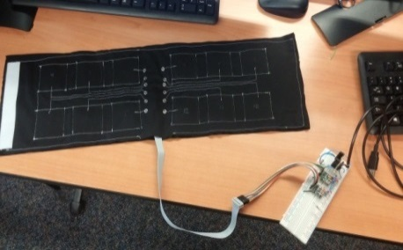

*Figure 2: Fabric tactile sensor*

One of my favorite parts of the RaD Lab is the many outreach opportunities I’ve had as a lab member. I have given multiple lab tours to new freshman to get them excited about research. I also worked with other students in the lab to bring our robots to the Utah STEM Fest to introduce younger students (elementary, middle, and high school age) to robotics and STEM. Hundreds of students were able to interact with our robots.

## The Aerospace Corporation – 2016

This past summer, I worked at a second federally funded research and development center, The Aerospace Corporation. While there, I worked primarily on three projects. First, I designed, built, and calibrated a testing setup to measure the thrust generation of a new type of UAV in Martian atmosphere. This included selecting vacuum compatible load cells, designing all of the mounting hardware, and writing the LabVIEW code to collect the data. Second, I was responsible for determining the heat transfer rate of new thermoelectric cooling modules. The Aerospace Corporation was researching these modules as a potential replacement for cyrocoolers on satellites. I designed a test plan and wrote a thermal PID controller in LabVIEW that controlled the temperature difference across the module. My LabVIEW code completely automated the data collection. To tune the PID controller, I performed system identification to create a first order model and simulated its response in Simulink. Third, I wrote a gradient based optimization in Matlab to orient six accelerometers on a reaction wheel jitter test stand (again using LabVIEW for data collection).

This internship reinforced my love of working in a research based environment with real hardware. I want the algorithms I develop during my graduate research to influence the lives of real people. This means that they will need to be implemented on real hardware. This experience in working with control system design on real hardware has been invaluable in preparing me for graduate research in controls and robotics.

# How Graduate School Will Prepare Me to Help Expand Scientific Understanding

## Continued Research

I am pursuing my master’s degree in the RaD Lab at BYU where I will research multi-arm manipulation with soft, pneumatically actuated robots. As a part of this research, I will develop advanced dynamic models, write and implement controllers, and work with a variety of robots. This experience in solving open ended problems will be priceless for my future career. I will also have the opportunity to present my research at multiple conferences where I will collaborate with other researchers in my field. In short, my graduate degree will enable me to work shoulder-to-shoulder with other experts to address some of the nation’s most difficult challenges.

## Future Career

Through my internships at The Aerospace Corporation and Los Alamos National Laboratory, I learned that I will greatly enhance my potential to benefit society through cutting edge research with a graduate degree. During both these internships and my undergraduate research, I made contributions that expanded scientific understanding. I fully intend to do similar research throughout my career. In fact, my research and experimentation at The Aerospace Corporation was received well enough that they kept me on as a temporary employee while working on my master’s degree. This means I have the option of returning there after the completion of my graduate degree to contribute to the nation’s scientific understanding of dynamics and control in space applications.

# How Graduate School Will Prepare Me to Broadly Benefit Society

## Giving Back

The entirety of my undergraduate studies was paid for through academic scholarships, which allowed me to spend more time focusing on my research and classes. These scholarships are provided by the generosity of others. I have already given back financially after earning my bachelor’s degree. A graduate degree will enable me to give back more generously both financially and in terms of time donated to help young, hardworking researchers in STEM accomplish their ambitions.

## Volunteering

Throughout my life, I have demonstrated a pattern of regular service which I fully intend to continue. In high school, I did a service project each month as part of a church program while also working to earn my Eagle Scout award (designing and building a wheelchair accessible rest area on a walking path for the community). After completing my first year of college, I spent two consecutive years as a volunteer missionary in Jamaica. During these years, I spent 16 hours a day teaching, building houses, constructing chicken coops, clearing farmland, and performing other acts of humanitarian service. This experience opened my eyes to the challenges that face much of the world, and reinforced my desire to make a difference. Since returning to school after my missionary service, I have continued to participate in outreach opportunities. I volunteered for a 10 week program focused on strengthening families where I worked with a group of at risk, minority teenagers once a week. Additionally, I have participated in multiple outreach opportunities as a member of the RaD Lab where we gave hand-on demonstrations of the lab’s research and robots.

Technical demonstrations by RaD Lab graduate students greatly influenced my decision to pursue a graduate degree. I’m thrilled to be a part of this lab, and will continue participating in similar outreach activities both during and after graduate school.

# Conclusion

British philosopher, Herbert Spencer stated, “The great aim of education is not knowledge but action.” This is how I feel about my education. Obtaining a graduate degree will empower me to help change the world, and I eagerly anticipate what lies ahead.

[1] I. Acevedo, R. Kaleb Kleine, D. Kraus, and D. Mascareñas, “Multimodal sensing strategies for detecting transparent barriers indoors from a mobile platform”, in *Proc. SPIE 9431, Active and Passive Smart Structures and Integrated Systems 2015*, 94310V, 2015.